

Lifion Developer Candidate Case Study

Video Streaming Service

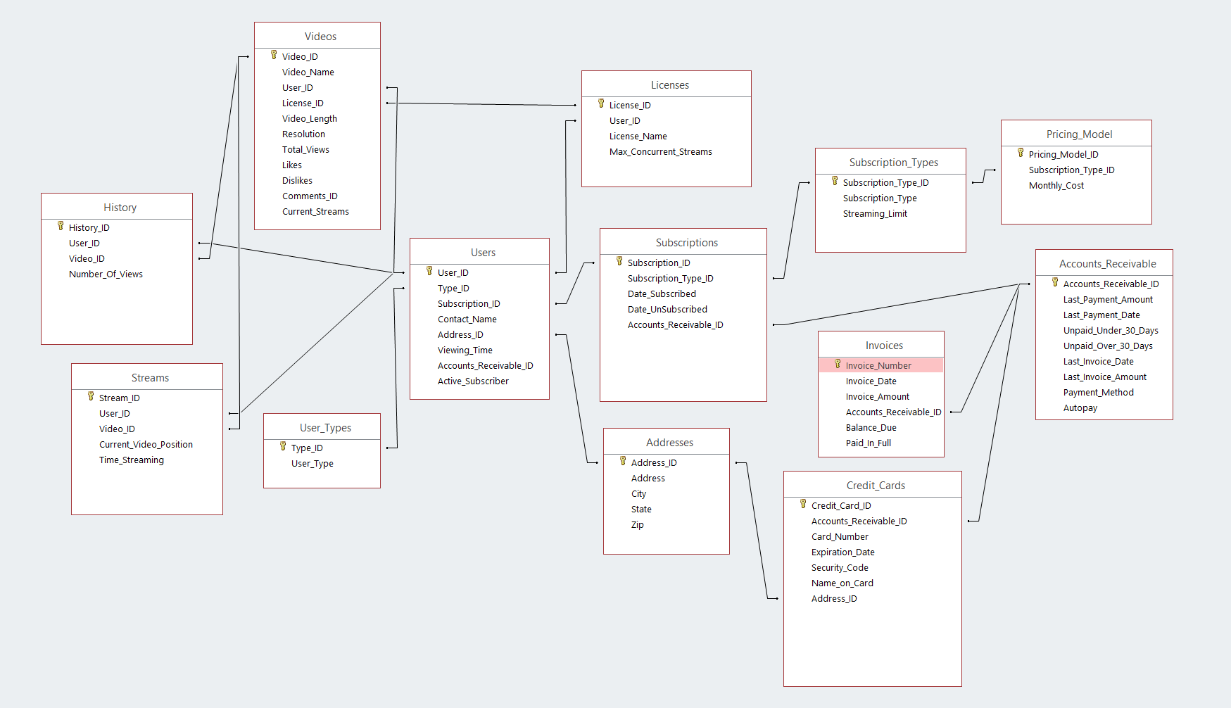**ER Diagram**

**SQL Query –**

SELECT TOP 20

Users.Contact_Name,

Videos.Video_Name,

History.Number_Of_Views

FROM (

History

INNER JOIN Users

ON Users.User_ID = History.User_ID

)

INNER JOIN Videos

ON Videos.Video_ID = History.Video_ID

ORDER BY History.Number_Of_Views DESC;

**Algorithm –** can also be found at - <https://github.com/adjit/Lifion/blob/master/Lifion.cs>

using System;

using System.Collections.Generic;

public class CheckSubs

{

/* Function doesn't need it's own class */

public CheckSubs(Dictionary<int, Subscriber> subscribersAR, List<Invoice> invoices)

{

/* Couple of things here --

*

* subscribersAR will be a dictionary of subscribers using the Accounts_Receivable_ID

* as the key for easy AR access.

*

* Alternatively, you could pass just plain list of subscribers to the function and

* put the subscribers into a dictionary with the Accounts_Receivable_ID, but that

* would be better off handled by some main process that would create necessary

* dictionaries. Let's say multiple functions would use the subscribersAR - don't

* want to go through the process of setting up a dictionary multiple times.

*

* Since the Database will handle account ageing and updating account balances

* and amounts due under 30 days and amounts due over 30 days, finding which

* subscribers are delinquent is a trivial process of checking which accounts

* have balances over 30 days.

*

* However, lets say it's ok to be over 30 days but under 60 days. The db

* doesn't have Over 60 days - you could add that data column in your database

* which will be updated by the ageing process and then again this would be a

* trivial process. Check if subscribers have amounts due over 60 days.

*

* For this case, will assume that the over 30 and under 30 variables are

* not available and need to check invoices

*

*/

DateTime now = DateTime.Now.Date;

/* Dictionary using the Accounts_Receivable_ID as it's Key and has a list of

* delinquent invoices as its Value.

*/

Dictionary<int, List<Invoice>> delinquentSubs = new Dictionary<int, List<Invoice>>();

/* Loop through all invoices that are passed

*/

for (int i = 0; i < invoices.Count; i++)

{

/* If the invoice is younger than 60 days move on, subscriber can

* still pay. The value doesn't have to be 60 days. You could add

* a variable that would used to check. Just using 60 for this

* example

*/

if (now.Subtract(invoices[i].invoiceDate).Days < 60) continue;

/* Otherwise, invoice is way over-due and the customer needs to

* be informed their account will be cancelled. But, the subscriber

* may have multiple open invoices, so just put delinquent invoices

* into the delinquentSubs dictionary using the Accounts_Receivable_ID

* as the key

*/

else

{

List<Invoice> delinquentInvoices;

int key = invoices[i].ARID;

/* Try to get the key value in delinquentSubs. If that value doesn't

* exist, then create a new invoice list for that key, and then add

* the delinquent invoice to that list.

*/

if (!delinquentSubs.TryGetValue(key, out delinquentInvoices))

{

delinquentInvoices = new List<Invoice>();

delinquentSubs[key] = delinquentSubs;

}

/* Could choose to notify the delinquent sub here, but what if they have multiple

* invoices outstanding. Could result in multiple messages being sent. Why not just

* collect all delinquent invoices and then send them all at once. *

*/

delinquentSubs[key].Add(invoices[i]);

}

}

/* Go through all items in the delinquentSubs dictionary and notify

* the subscribers of delinquent invoices.

*/

foreach(var item in delinquentSubs)

{

subscribersAR[item.Key].notifyDelinquent(item.Value);

}

}

}

/* Payment object - not used in this scenario, but would be

* used to get more information about payments

*/

public class Payment

{

public DateTime PaymentDate;

public int PaymentAmount;

}

/* Invoice class which takes the corresponding data from the

* database and turns it into a usable object

*/

public class Invoice

{

public DateTime invoiceDate;

public int invoiceNumber;

public int invoiceBalance;

public int invoiceAmount;

public int ARID;

public Invoice(DateTime date, int num, int bal, int amt, int arID)

{

invoiceDate = date;

invoiceNumber = num;

invoiceBalance = bal;

invoiceAmount = amt;

ARID = arID;

}

}

public class Accounts_Receivable

{

int Amount_Due_Under_30;

int Amount_Due_Over_30;

List<Payment> Payments;

public Accounts_Receivable(int ARID)

{

/* Query Database for AR data including

* payments and load into class variables

* Database should take care of Ageing and

* updating and amount due

*/

}

}

/* Contact Information class that would be used when

* sending subscribers notices. This object contains

* the subscribers contact information.

*/

public class Contact_Information

{

public string contact;

public string address;

public string city;

public string state;

public string zip;

public string email;

public string phone;

}

public class Subscriber

{

/* Only allow people to get variables

* Changes need to be handled by the class

*/

private string _sub;

private int _subID;

private int _ARID;

private Accounts_Receivable _AR;

private Contact_Information _CI;

public string subscriber { get { return _sub; } }

public int subscriber_ID { get { return _subID; } }

public int Accounts_Receivable_ID { get { return _ARID; } }

public Accounts_Receivable AR { get { return _AR; } }

public Contact_Information CI { get { return _CI; } }

/* Contacts, address's etc.

* Class will be passed all variables or make

* the proper function calls to retrieve the

* database information and gather it

*/

public Subscriber(string sub, int subID, int arID)

{

/* Basic constructor - only set subscriber and ID's */

_initialize(sub, subID, arID);

}

public Subscriber(bool get_AR, string sub, int subID, int arID)

{

/* Overload Subscriber to load various

* items upon initialization. In this case:

*

* Flag to get AR upon initialization

* - what if we didn't need that data?

* pointless to load it in otherwise

*

* Can add more flags in the future

*/

_initialize(sub, subID, arID);

_loadAR();

}

public void notifyDelinquent(List<Invoice> invoices)

{

/* Send email / mail subscriber a delinquency notice of cancellation

* and delinquent invoices

*/

}

public void Load_Accounts_Receivable()

{

/* Function to use if you want to load in AR later

* or refresh

*/

_loadAR();

}

/* Initializes the basic subscriber values that will always be passed.

* Since there may be overloading in this class, instead of each function

* setting these 3 variables this one function will handle that

*/

private void _initialize(string sub, int subID, int arID)

{

_sub = sub;

_subID = subID;

_ARID = arID;

}

private void _loadAR()

{

_AR = new Accounts_Receivable(_ARID);

}

}

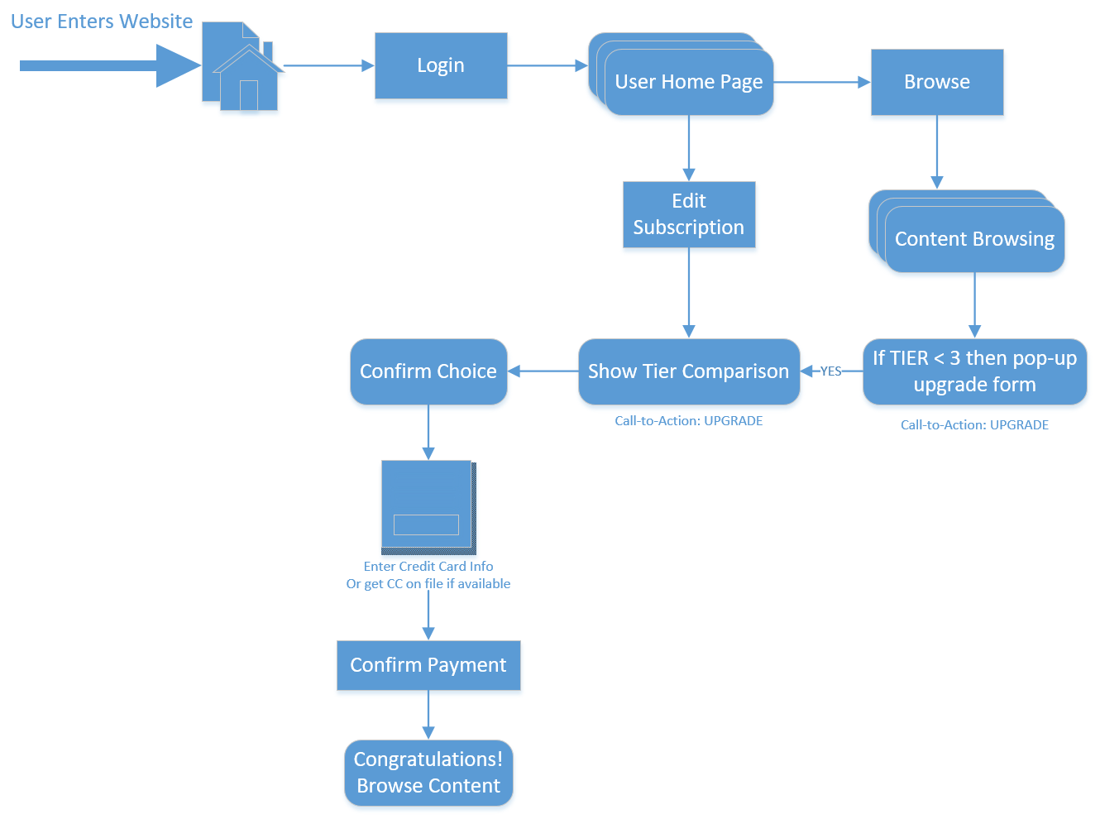**Product/UX**

**Case Overview & Requirements**

“Vidsi” is a new video streaming service you are building for a startup company.

* Subscribers sign up for free and receive 2 hours of free streaming
* For paid subscribers, streaming limits are based on plan tier
* There are currently 3 tiered subscription plans - but they may change in the future
* There’s a catalog of videos to stream that are licensed from different content providers
* Subscribers stream videos and we need to store information about what’s being streamed
* We need to generate monthly invoices for subscribers that can be paid by credit card on file or by check
* For subscribers charged by credit card we need to store payment information (you can assume security and PCI compliance don’t exist - you can store credit card numbers to charge)
* Licenses with content providers only allow for a certain number of concurrent subscribers to watch a given video

**Data Modeling**

Given the above requirements please create a data model in the form of a complete physical entity relationship diagram (ERD). Your diagram should be comprehensive and sufficient for creating a relational database schema that will support the applications’ requirements.

**SQL Query**

Write a SQL query to return the top 20 video/user pairings. In other words, show which videos have been most re-watched by a single user.

For example:

User A, Video A, 30 Views

User B, Video A, 29 Views

User B, Video B, 19 Views

User A, Video C, 18 Views

**Algorithm**

Write a function that, given a list of invoices and subscribers, would find subscribers who haven’t paid their invoices and need to be sent a cancellation notice.

You can use pseudo code or any programming language of your choice to write this!

**Product/UX** (Optional)

Create a process flow/wireframes that would show how subscribers would change their subscription from free to paid tier.